MISSISSIPPI STATE UNIVERSITY COLLEGE OF VETERINARY MEDICINE
Canine Cyclosporine Pharmacodynamic Assay (Immune Function via PCR Assay for IL-2)
Please type in information and then print it. If form is filled in by hand, please use only capital letters to fill the blanks.

Veterinarian Information: | Billing Information (must complete for samples to be processed):
Name: | Clinic Name:
 | Street Address:
 | City, State, ZIP:
Email: | Phone Number:

Patient Information

Dog’s Name |  |  |  |  |  |  | Owner’s Name
Case/Ref. Number |  |  | Breed |  |  | Age (Years) | Weight (Kg) | Gender (M/F) | Neutered (Y/N)
Current Diagnosis
Current History (please fill in all the necessary information) NOTE: Medication history goes in following section.
Changes from previous history?
(if previous samples submitted, please fill in all significant changes)
Clinical Signs Controlled? (Y/N) |  |  |  |  | In Remission? (Y/N, plus extra details if needed)

Current Treatment

Drug Name (excluding cyclosporine) | Dose (mg) | Frequency | Drug Name | Dose (mg) | Frequency
 |  | Every hrs |  |  | Every hrs
 |  | Every _hrs |  |  | Every hrs
 |  | Every _hrs |  |  | Every hrs
 |  | Every _hrs |  |  | Every hrs
 |  | Every hrs |  |  | Every hrs

Sample Information

Date of Collection (m/d/y) | Time (am/pm) | How Many Hours AFTER Cyclosporine Administration?

Cyclosporine Current Treatment (check relevant box):

Atopica® |  |  |  |  | Neoral® |  |  |  |  |  |  | Sandimmune® |  |  |  |  | Compounded |  |  |  | Generic
Modified (microemulsified, ultramicronized)? |  |  |  |  |  |  | Yes |  |  | No |  |  |  |  | Don’t Know
Manufacturer
Compounding Pharmacy (only for compounded cyclosporine)
Dose (mg/kg) |  |  |  | Frequency |  |  |  |  |  |  | Start Date (m/d/y)
 |  |  |  | Every hrs
Any Side-effects Observed? Yes No
(If yes, please cite):

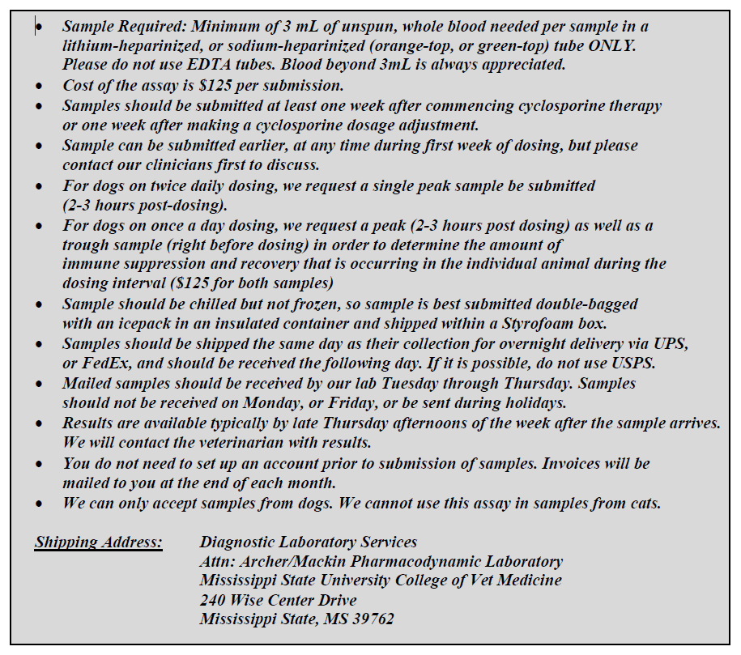

CONTACT

Lakshmi Narayanan, Senior Research Associate, lna45@msstate.edu; (662) 312-8138 (laboratory)

Please feel free to contact us if you have any questions regarding sample submission or results.

CLINICIANS

Dr. Todd Archer, Professor: tarcher@cvm.msstate.edu; (662) 325-1266

Dr. Andrew Mackin, Professor and Department Head; mackin@cvm.msstate.edu; (662) 418-3277

